**Ideation Phase**

**Empathize & Discover**

|  |  |
| --- | --- |
| Date | 21 August 2025 |
| Team ID |  |
| Project Name | shopEZ One-Stop Shop For Online Purchases |
| Maximum Marks | 4 Marks |

**Empathy Map Canvas:**

ShopEZ is your one-stop destination for effortless online shopping. With a user-friendly interface and a comprehensive product catalog, finding the perfect items has never been easier. Seamlessly navigate through detailed product descriptions, customer reviews, and available discounts to make informed decisions. Enjoy a secure checkout process and receive instant order confirmation. For sellers, our robust dashboard provides efficient order management and insightful analytics to drive business growth. Experience the future of online shopping with ShopEZ today.

seeking consistent work through a platform like Freelance Finder.

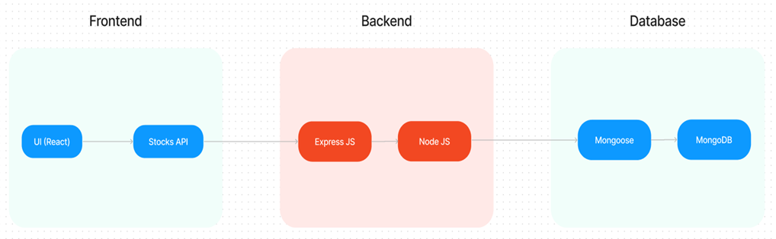

In this architecture diagram:

• The frontend is represented by the "Frontend" section, including user interface components such as User Authentication, Cart, Products, Profile, Admin  dashboard, etc.,

• The backend is represented by the "Backend" section, consisting of API endpoints for Users, Orders, Products, etc.,It also includes Admin Authentication and an Admin Dashboard.

•  The Database section represents the database that stores collections for Users, cart, Orders and Product.